

**Atilim University**

**Software Engineering Department**

**SE 112**

**Introduction to Software Engineering**

**2023-2024 (II)**

**Prof. Dr. Ali YAZICI**

**Res. Asst. Arif Eren DUMANLI**

**Assignment 1 and 2**

**BUILDING THE LEGAL SUMMARIZER**

**Group-26 members:**

* **23244710010 - Ege KAZKAYASI**
* **22244710089 - Muhammet Berke ARICI**

**Contents:**

**Building the Legal Summarizer** 1

Problem Description: 1

**Project Management** 2

Project Plan: 2

In The Gantt Chart, The Representation of The Project: 2

Risk Assessment: 3

**Requirements:** 4

**User Story:** 5

**Use Case Diagram:** 5

**Class Diagram:** 7

**The Activity Diagram:** 9

**FIGMA:** 9

# **Building the Legal Summarizer**

## Problem Description:

The aim of the project is to be able to summarize and refine the legal terms and conditions documents to make them more digestible, easier to understand and less time consuming for users so that they may make more informed decisions and exercise more consent when accepting to a “terms and conditions” agreement In the pursuit of this goal we plan to develop an application to increase intelligibility for users .The “Legal Summarizer” or *Shorten* is an artificial intelligence based application that analyzes and then summarizes and shortens any “terms and conditions” document, “user agreement” forms or any such legal contract users receive from websites, apps and other software.    We feel there is a major need for a project like this for according to a paper published by Berkeley University the percentage of users who read the terms and conditions agreements may be as low as 1%  The Legal Summarizer will analyze terms and conditions agreements and then summarize the text. Increasing the clarity without losing important legal points. The methodology of this project focuses on improvimg the Understandability of legal documents to enable users to make more informed decisions and give consent.

**-Citation :**“Do We Actually Agree to These Terms and Conditions?” *Data Science W231 Behind the Data Humans and Values*, Berkeley University, 20 July 2021, blogs.ischool.berkeley.edu/w231/2021/07/09/do-we-actually-agree-to-these-terms-and-conditions/#:~:text=In%20fac.

# **Project Management**

## Project Plan:

|  |  |  |  |
| --- | --- | --- | --- |
| **TASK** | **TIME (week)** | **ACTIVITY** | **DEPENDS ON** |
| A | 1 | **Researching**: Finding out which users it can appeal to. Analysis of text summarization techniques. Investigation of AI algorithms. Looking at other AI applications. |  |
| B | 1 | **Collecting Resources and Creating Infrastructure**: Collecting of necessary data information and installation of the necessary software infrastructure for text summarization. | A |
| C | 3 | **Development of Summarization Algorithm**: Coding of an artificial intelligence that can summarize texts. Development of a mechanism for the automatic evaluation of the created abstracts and the provision of feedback. | A-B |
| D | 2 | **The Experience Process and User experience**: Conducting usability test, error situations are handled and interface improvement studies according to user feedback. | C |
| E | 1 | **Integration With Other Applications:**  applications are selected where users cannot continue their transactions without approving texts and these applications and our artificial intelligence supported text summarization project are enabled to work together. | C |
| F | 1 | **Announcement of the project:**  our text summarization project supported by artificial intelligence is announced to users through the applications we work with and social media. | D |

## In The Gantt Chart, The Representation of The Project:

metin, ekran görüntüsü, öykü gelişim çizgisi; kumpas; grafiğini çıkarma, çizgi içeren bir resim

Açıklama otomatik olarak oluşturuldu

## Risk Assessment:

|  |  |
| --- | --- |
| **Risk 1:** Summarisation algorithm may miss important parts of the paragraph. | **Countermeasure 1:** Some lawyers who work with together will check the summarized paragraphs so, if they any wrong problem, The application will not be available until the application is maintained and fixed. |
| **Risk 2:** Many constitutions and legal systems have vulnerabilities that can be found out and exploited by large companies and their law departments. The app might not be able to recognize some of these more discrete susceptibilities | **Countermeasure 2:** Help from a legal experts and or such authorities can be sought as consultants for development  in order to train the AI to recognize such loopholes |
| **Risk 3:** The failure of the app in recognizing some legal compromise or a failure in its expression of such a compromise might result in a lawsuit against the app and its developers | **Countermeasure 3:** A short and concise consent form as well as disclaimer before the use of the app would clear the developer of any and all legal responsibility. |

# **Requirements:**

|  |  |  |
| --- | --- | --- |
| Functional Reqs ID | Explanation | MOSCOW priority (M, S, C, W) |
| FR1 | The application must accurately identify and extract the most important points of law from the document. | M |
| FR2 | Users should have the option to save and export the summarized page. | S |
| FR3 | The application should support a lot of languages for foreign users. | S |
| FR4 | For every summarized paragraph could have the ‘see more details’ button. | C |
| FR5 | Users could adjust to level of detail in the summary. | C |
| FR6 | Complex terms and concepts should be explained in the summarised documents using an interactive dictionary. | W |
| FR7 | Application rephrase section the user did not understand upon first reinterpretation if demanded | C |
| FR8 | Application should show the legal sources (constitution, documents etc.) | S |
| FR9 | Application should warn users of possible hostile intention or legal exploitative loopholes via alerts & exclamations. | S |
| FR10 | App must change difficult legal terminology into comprehensive, specific and easy to understand words, sentence & phrases | M |
| Non-Functional Reqs ID | Explanation | MOSCOW priority  (M, S, C, W) |
| NFR1 | The application's interface should be intuitive and user-friendly, requiring minimal training for users to navigate. | S |
| NFR2 | To be compatible with various operating systems, to enable users to use the application on different devices and platforms | C |
| NFR3 | App must inform the user that it is not equivalent to professional legal help & that if there is any concern such help should be sought. | M |
| NFR4 | Application should include a colour-blind & voice assist mode option for disabled users | W |

# **User Story:**

The user can choose to use the Legal summarizer whenever he or she receives a legal document or terms and conditions agreement via exporting. After receiving their summary the users can ask for more detail, a different explanation or the sources for the legal explanations (ex: according to KVKK article 7.1) The users have to accept a short agreement clarifying that the app is not a substitute for professional legal app and any and all responsibility from a legal misinterpretation is upon the user. And they have to login to the app if they want to use it.

# **Use Case Diagram:**

@startuml

actor User

rectangle "Legal Summerizer" {

usecase "Login"

usecase "Summarize"

usecase "Use different explanation"

usecase "Show source"

usecase "Rephrase"

usecase "Verify Password" as VerifyPassword

usecase "Show Error Message" as ShowErrorMessage

}

User --> Login

User --> Summarize

User --> "Use different explanation"

User --> "Show source"

User --> Rephrase

Login --> VerifyPassword

Login --> ShowErrorMessage : <<extends>>

@enduml

**Based on Code:**

**diyagram, taslak, metin, çizgi içeren bir resim

Açıklama otomatik olarak oluşturuldu**

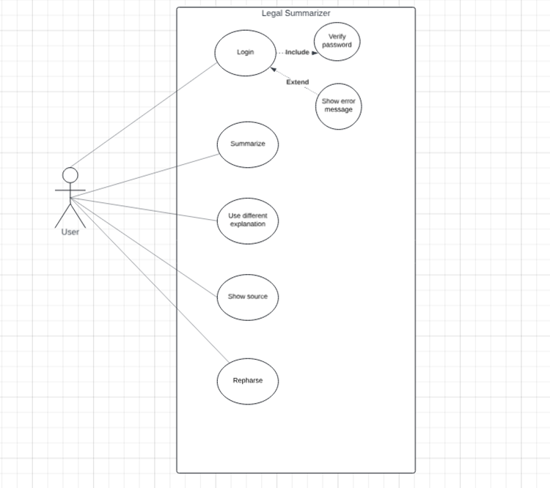**The Better Looking Version:**

# **Class Diagram:**

@startuml

class "Legal Summarizer" {

+Name

+Username

+Password

-Login()

}

class User {

+Name

-Rephrase()

-Summarize()

-OtherDocument()

-AddDetail()

}

class "Legal Document" {

}

class "Terms and Conditions Agreement"

class Contract

class Lawsuit

class "Other Document"

"User" --|> "Legal Summarizer" : Association

"Legal Document" --|> "Legal Summarizer" : Association

"Terms and Conditions Agreement" --|> "Legal Document" : Association

Contract --|> "Legal Document" : Association

Lawsuit --|> "Legal Document" : Association

"Other Document" --|> "Legal Document" : Association

@enduml

**Based on Code:**

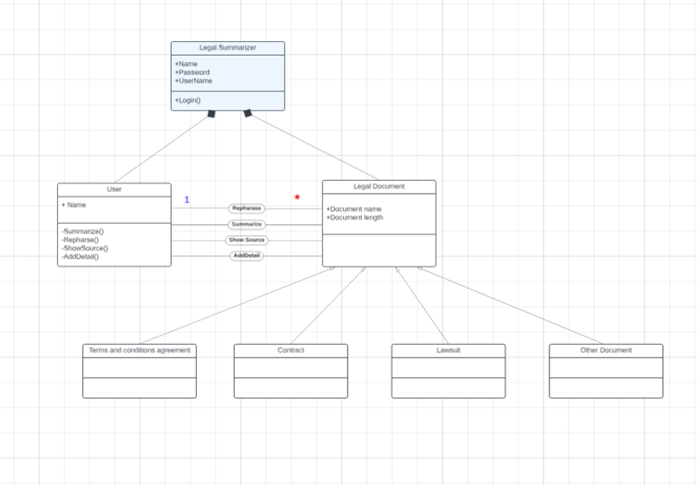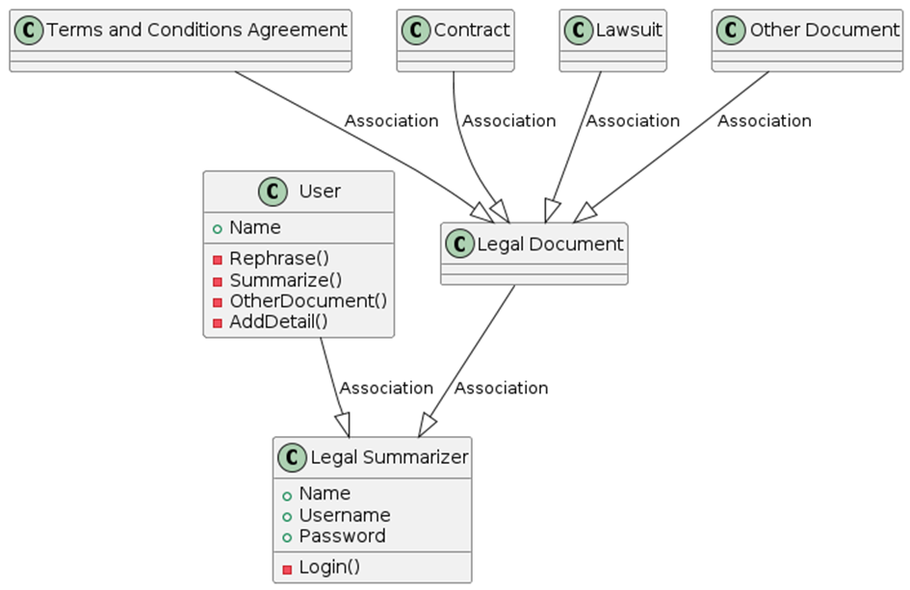

**The better looking version:**

# **The Activity Diagram:**

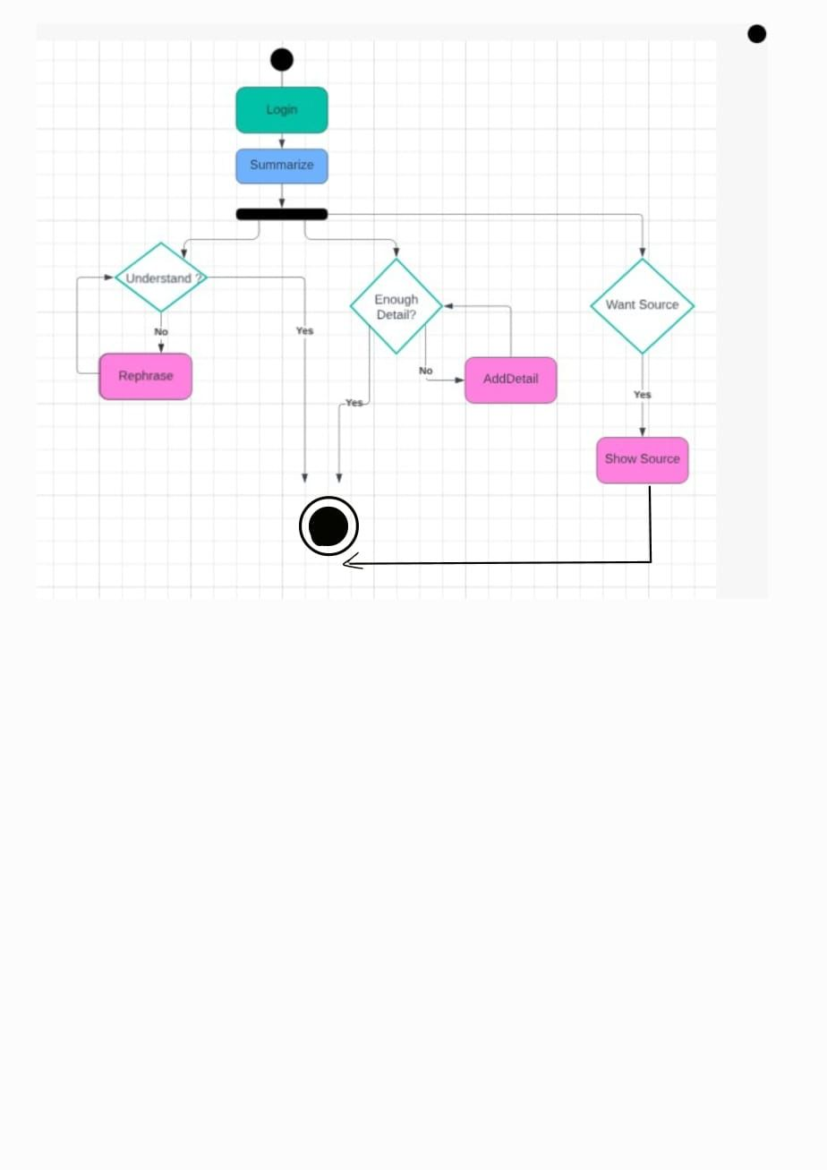

# **FIGMA:**

